**Project 3:How to connect private server to the internet using NAT gateway: (Jump server/Bastion host)**

* **Subnet created as nithin-private-subnet1**

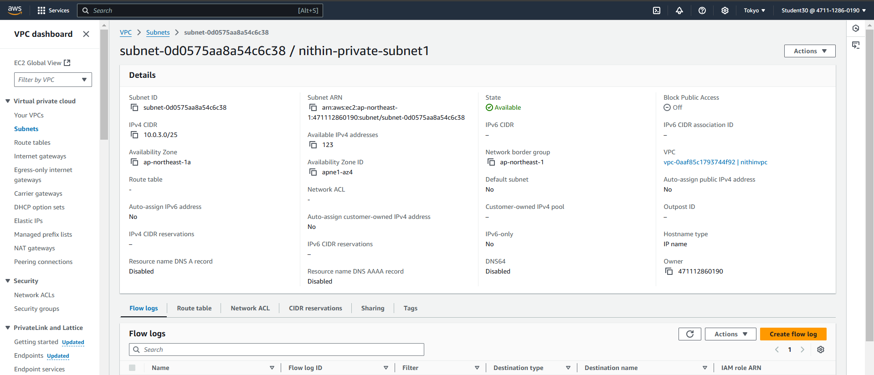

* **Subnet created as nithin-private-subnet2**

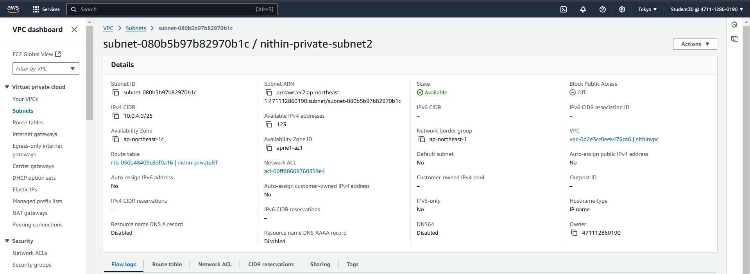

* **Route table created as nithin-privateRT**

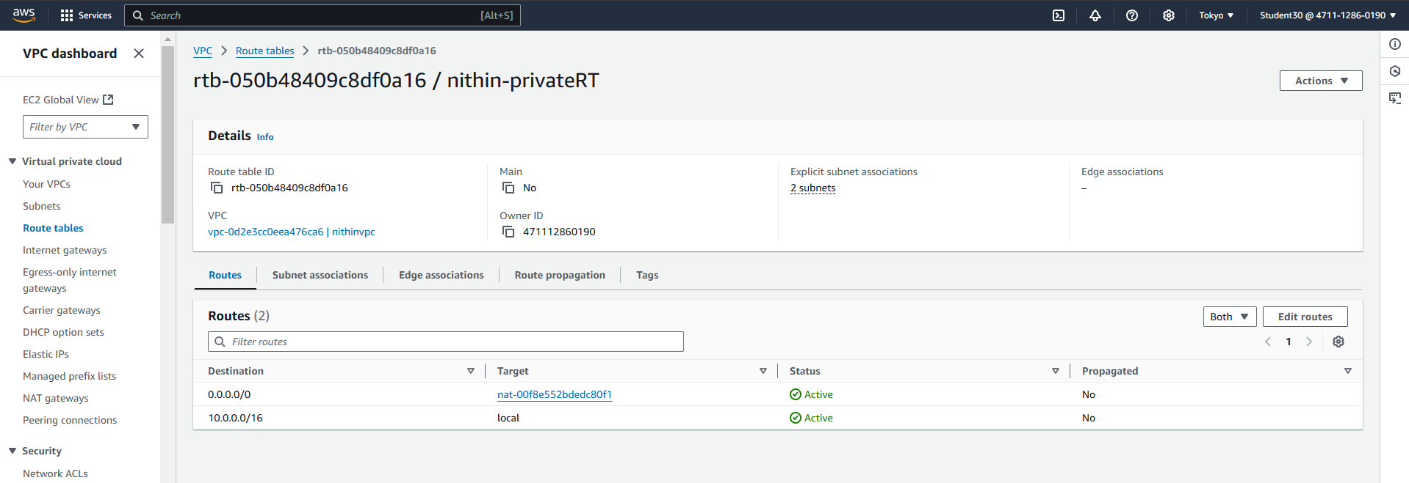

* **NAT gateways created as nithin-nat-gateway**

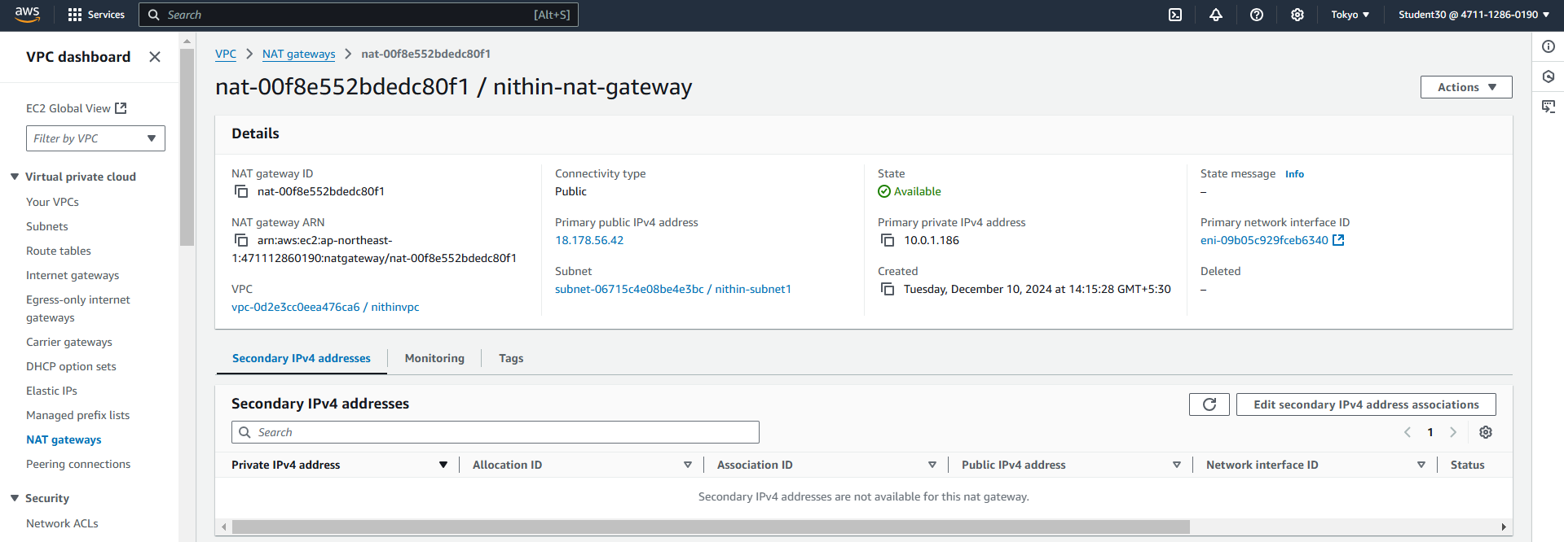

* **Edit routes**

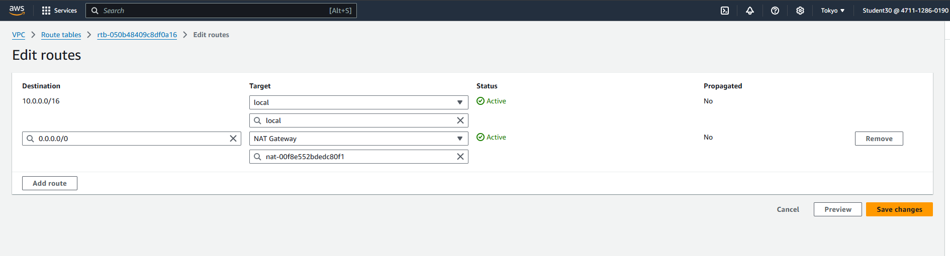

* **Creating private server in private subnet**

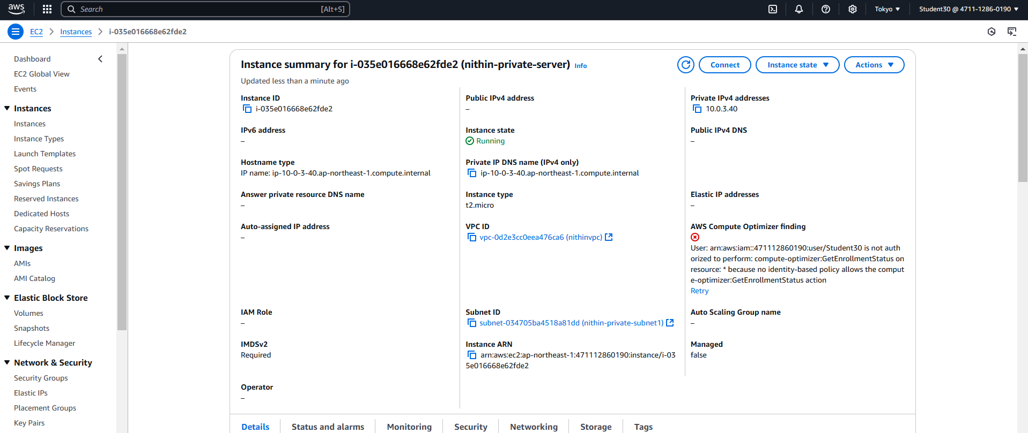

* **Command prompts**

